JSON FILES
Step 1: Login to SnowSQL
snowsql -a <account_name> -u <username>
Step 2: Select Database, Schema, Warehouse
Create database Assessment_Json;
Use schema public;
Step 3: Create Table
CREATE OR REPLACE TABLE employee_json (
raw VARIANT
);
Step 4: Create Stage
CREATE OR REPLACE STAGE stage_ass1;
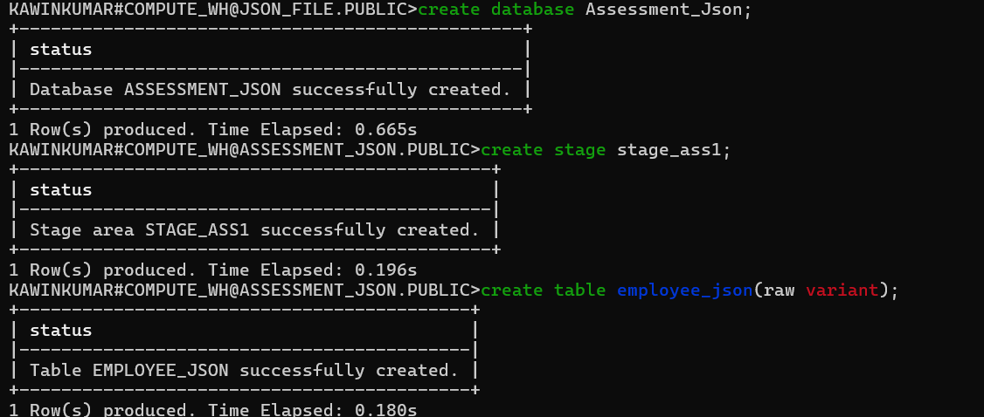
Step 5: Create File Format
CREATE OR REPLACE FILE FORMAT ff_json_flat
TYPE = 'JSON'
STRIP_OUTER_ARRAY = FALSE;
Step 6: Upload JSON File
PUT ‘file://c:/Users/sarav/Downloads/json_ass1.json’ @stage_ass1;
Step 7: Copy Data into Table
COPY INTO employee_json
FROM @stage_ass1/json_ass1.json
FILE_FORMAT = (FORMAT_NAME = 'ff_json_flat');
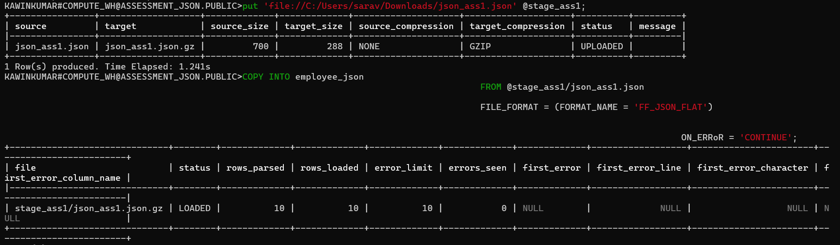

Step 8: Verify Data
SELECT * FROM employee_json;
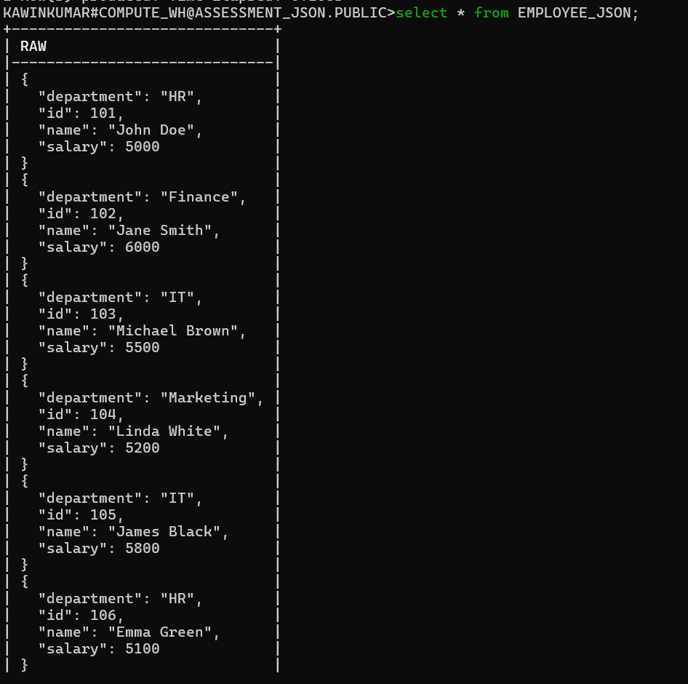
Step 9: Query JSON Fields
SELECT
raw:id::INT AS id,
raw:name::STRING AS name,
raw:department::STRING AS department,
raw:salary::INT AS salary
FROM employee_json;
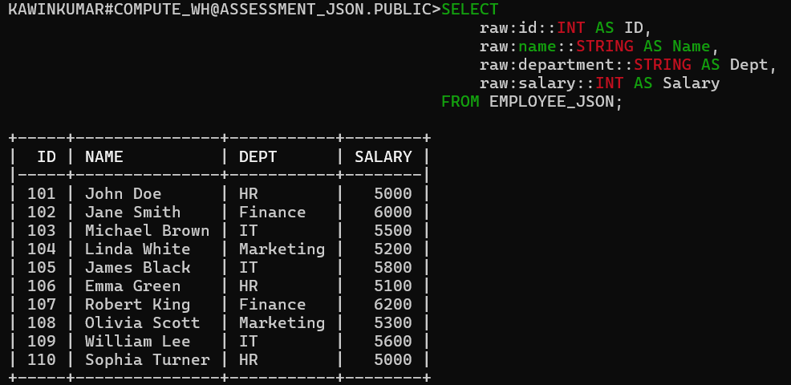
Purpose of This Query:
To extract data from a JSON column and convert it into a normal table format.
RAW:id
---RAW is your VARIANT column containing JSON data.
---RAW:id means → extract the value for the key "id" from the JSON object.
These are type casts.
Snowflake stores JSON as VARIANT, so to convert them to normal SQL types:
::INT → convert value into integer
::STRING → convert value into text string
------------------------------------------------------------------------------------------------------------------------------------------------------------------------------------------------------------------------------------------------------------------------------------------------------------------------------------------------------------------------------
Nested Json File
Step 1: Login to SnowSQL
snowsql -a <account_name> -u <username>

Step 2: Select Database, Schema, Warehouse
use DATABASE ASSESSMENT_JSON;
use schema ASSESSMENT2;
Step 3: Create Table
CREATE OR REPLACE TABLE EMPLOYEE_PROJECT_JSON (
raw VARIANT
);
Step 4: Create Stage
CREATE OR REPLACE STAGE json_nested;
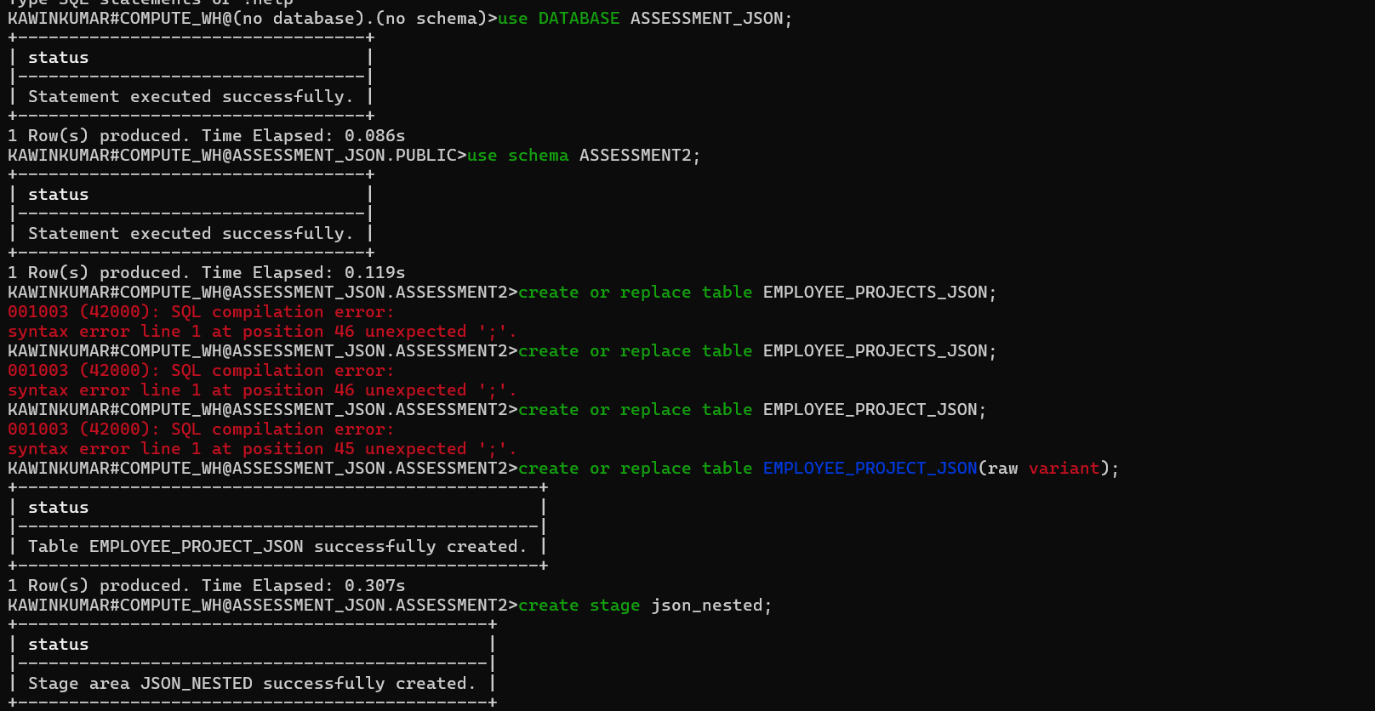

Step 5: Create File Format
CREATE OR REPLACE FILE FORMAT ff_json_flat
TYPE = 'JSON'
STRIP_OUTER_ARRAY = FALSE;
Step 6: Upload JSON File
PUT 'file://C:/Users/sarav/Downloads/json_ass2.json' @json_nested;
Step 7: Copy Data into Table
COPY INTO employee_project_json
FROM @json_nested/json_ass2.json
FILE_FORMAT = (FORMAT_NAME = 'FF_JSON_FLAT');
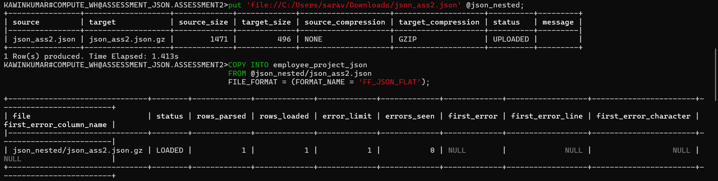
Step 8: Verify Data
SELECT * FROM employee_json;
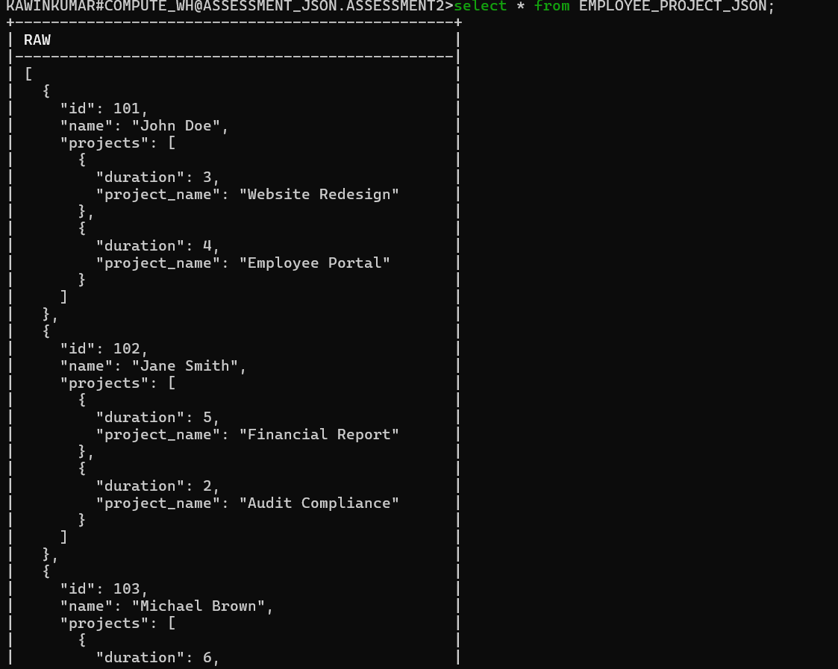
Step 9: Query JSON Fields
SELECT
emp.value:id::int AS employee_id,
emp.value:name::string AS employee_name,
proj.value:project_name::string AS project_name,
proj.value:duration::int AS duration
FROM EMPLOYEE_PROJECT_JSON,
LATERAL FLATTEN(input => raw) emp,
LATERAL FLATTEN(input => emp.value:projects) proj;

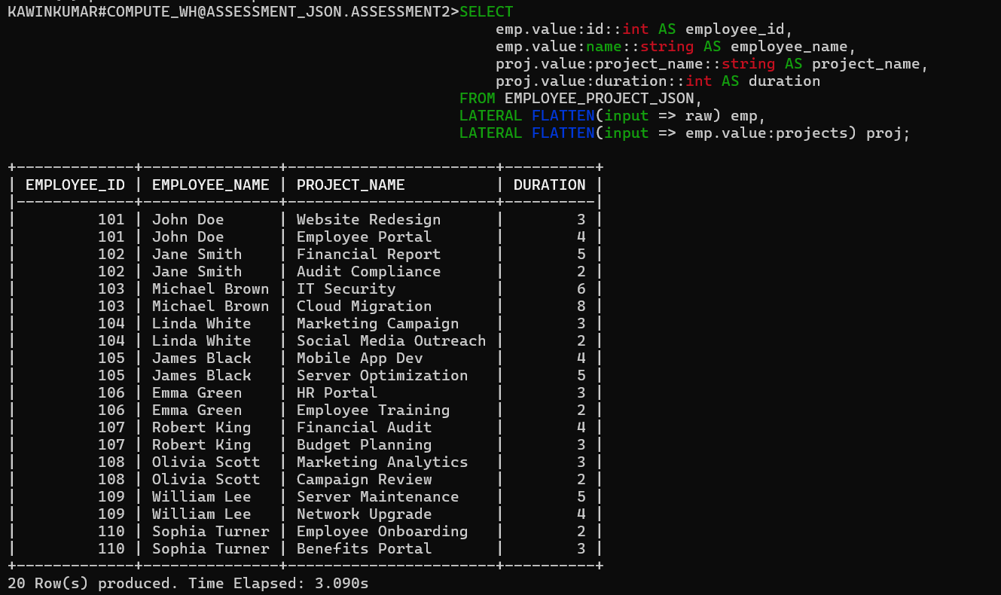
------------------------------------------------------------------------------------------------------------------------------------------------------------------------------------------------------------------------------------------------------------------------------------------------------------------------------------------------------------------------------
XML Files

Step 1: Create Table
CREATE OR REPLACE TABLE xml_table (
id INTEGER AUTOINCREMENT,
xml_doc VARIANT
);
Step 2: Create File Format
CREATE OR REPLACE FILE FORMAT my_xml_format
TYPE = 'XML'
STRIP_OUTER_ELEMENT = TRUE
COMPRESSION = 'AUTO';
Step 3: Upload JSON File
put 'file://C:/Users/sarav/Downloads/xml_ass1.xml' @xml_emp;
Step 4: Copy Data into Table
COPY INTO xml_table(xml_doc)
FROM @xml_emp/xml_ass1.xml
FILE_FORMAT = (FORMAT_NAME = 'MY_XML_FORMAT');

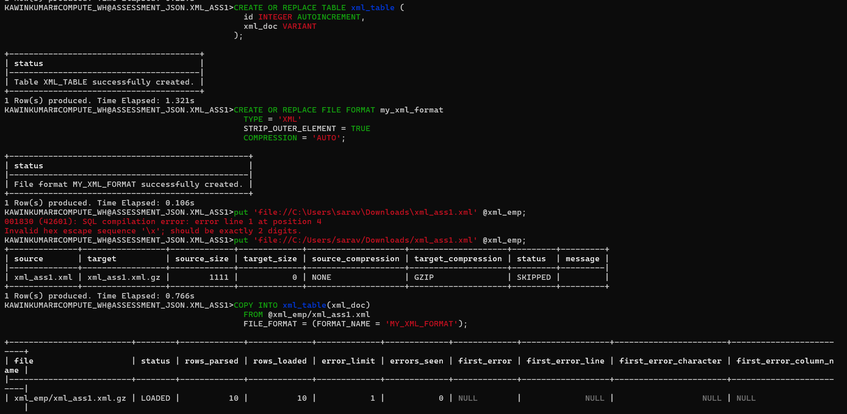
Step 5: Verify Data
select * from XML_TABLE;
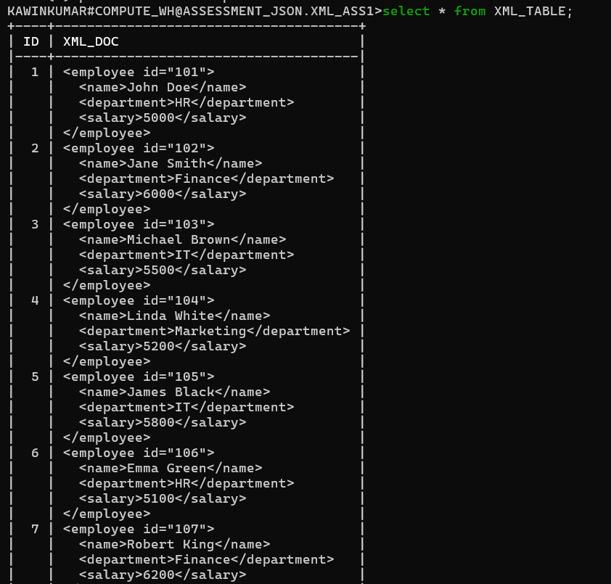
CREATE OR REPLACE TABLE EMPLOYEES_FINAL (
ID INT,
NAME STRING,
DEPARTMENT STRING,
SALARY INT
);
INSERT INTO EMPLOYEES_FINAL (ID, NAME, DEPARTMENT, SALARY)
SELECT
XML_DOC:"@id"::string::int AS ID,
XMLGET(XML_DOC, 'name'):"$"::string AS NAME,
XMLGET(XML_DOC, 'department'):"$"::string AS DEPARTMENT,
XMLGET(XML_DOC, 'salary'):"$"::int AS SALARY
FROM XML_TABLE;
select * from EMPLOYEES_FINAL;
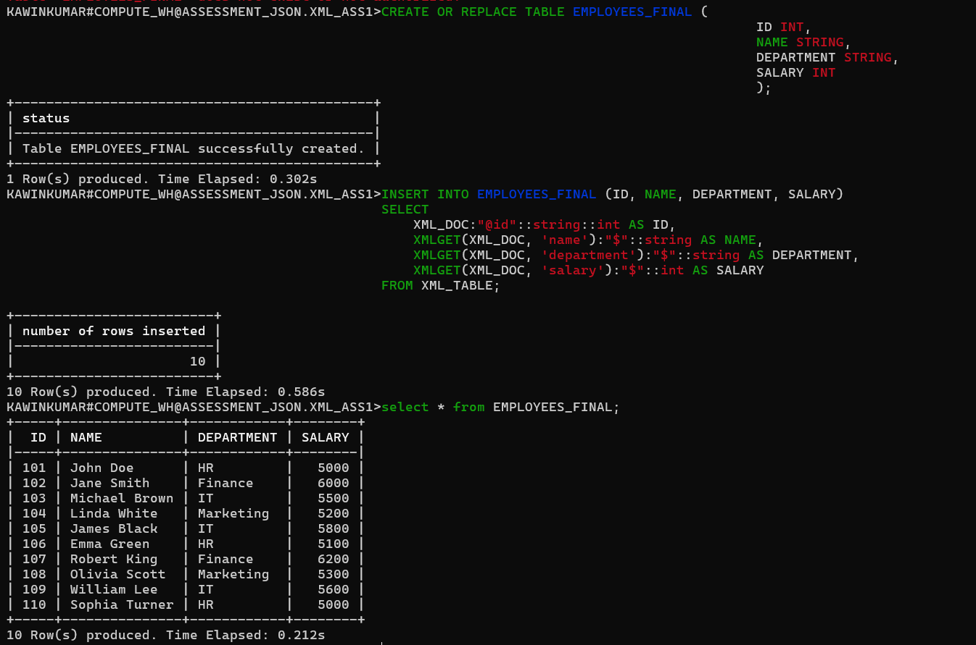

Query employee id, name, and department.

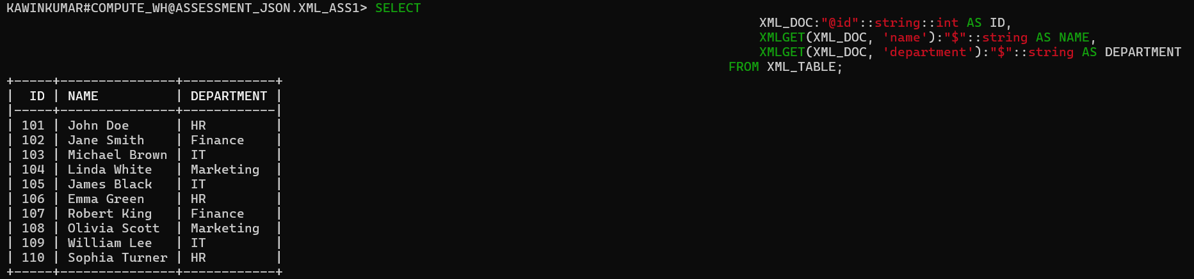

--------------------------------------------------------------------------------------------------------------------------------------
Nested XML FILE
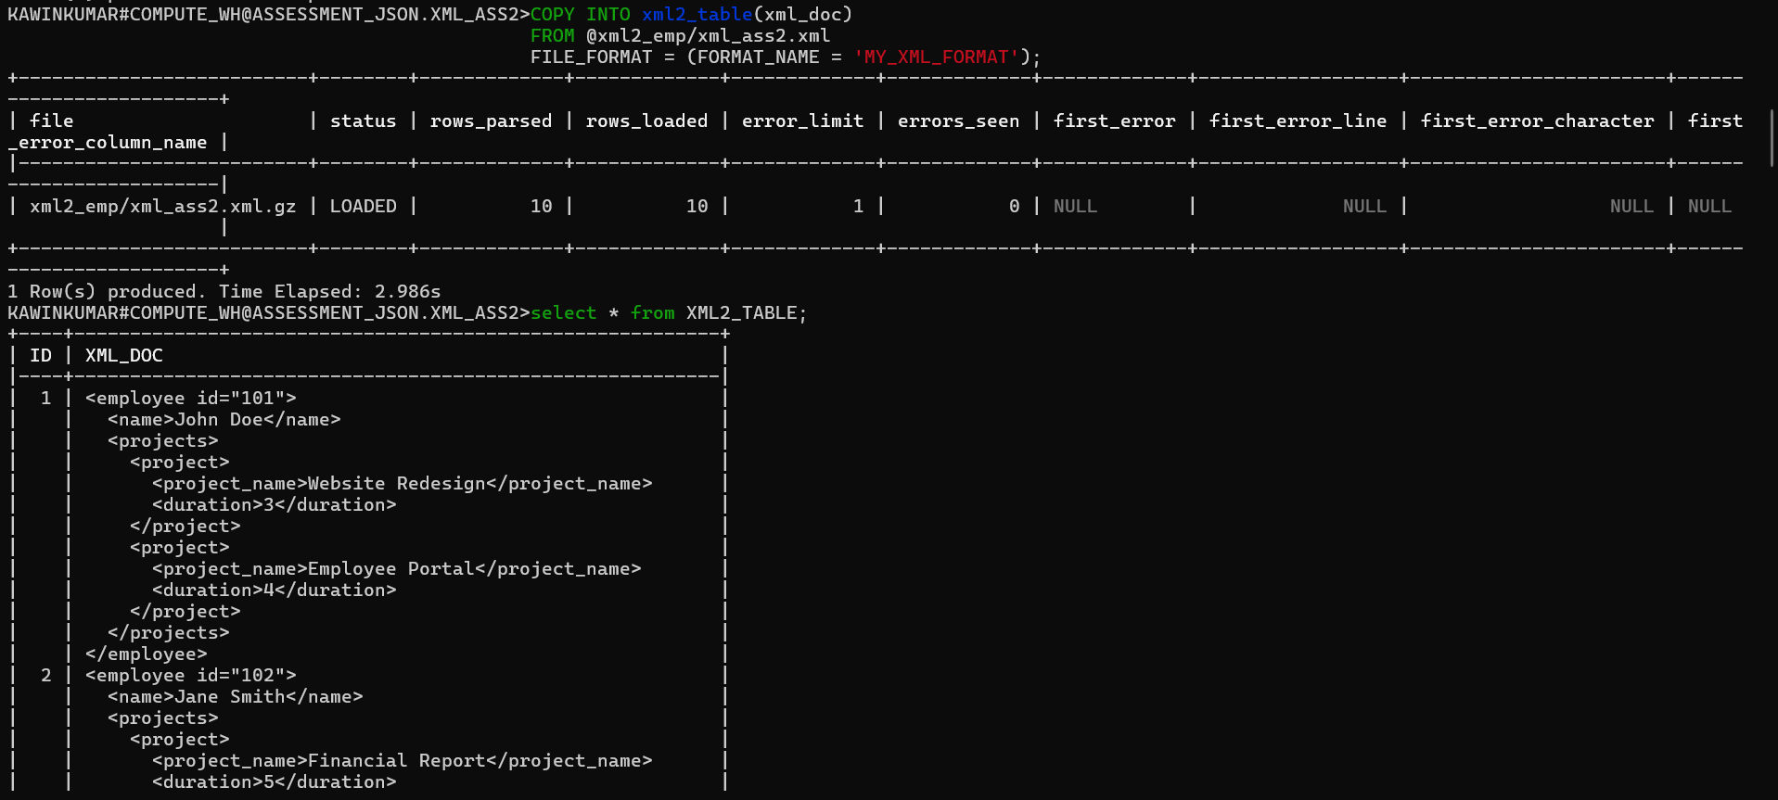

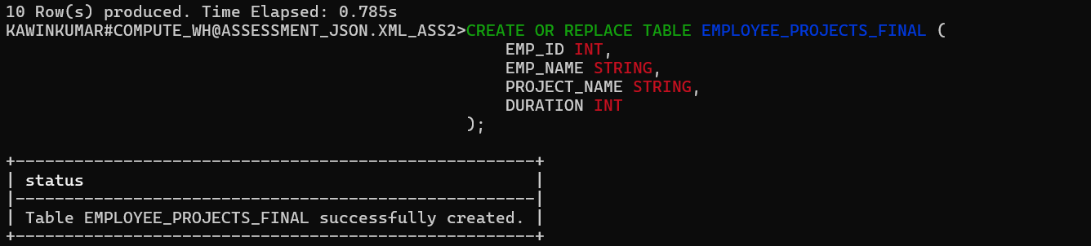
INSERT INTO EMPLOYEE_PROJECTS_FINAL (EMP_ID, EMP_NAME, PROJECT_NAME, DURATION)
SELECT
XML_DOC:"@id"::int AS EMP_ID,
XMLGET(XML_DOC,'name'):"$"::string AS EMP_NAME,
XMLGET(XML_DOC,'project_name'):"$"::string AS PROJECT_NAME,
XMLGET(XML_DOC, 'duration'):"$"::int AS DURATION
FROM XML2_TABLE;
